**DAILY ONLINE ACTIVITIES SUMMARY**

|  |  |  |  |  |  |  |  |  |
| --- | --- | --- | --- | --- | --- | --- | --- | --- |
| **Date:** | **31-05-2020** | | | | | **Name:** | **Nihal Rafiq** | |
| **Sem & Sec** | **4th A** | | | | | **USN:** | **4AL18CS052** | |
|  | |  | |  | | |  | |
| **Certification Course Summary** | | | | | | | | |
| **Course** | **Introduction to R** | | | | | | | |
| **Certificate Provider** | | | **Great Learning Academy** | | **Duration** | | | **2.5 hours** |
| **Coding Challenges** | | | | | | | | |
| **Problem Statement: 1. Write a java program to calculate nPr.** | | | | | | | | |
| **Status: Executed** | | | | | | | | |
| **Uploaded the report in Github** | | | | | **Yes** | | | |
| **If yes Repository name** | | | | | **https://github.com/nihal-art/lockdown-coding** | | | |
| **Uploaded the report in slack** | | | | | **Yes** | | | |

Certification Course Details:

I have opted to R certification course.

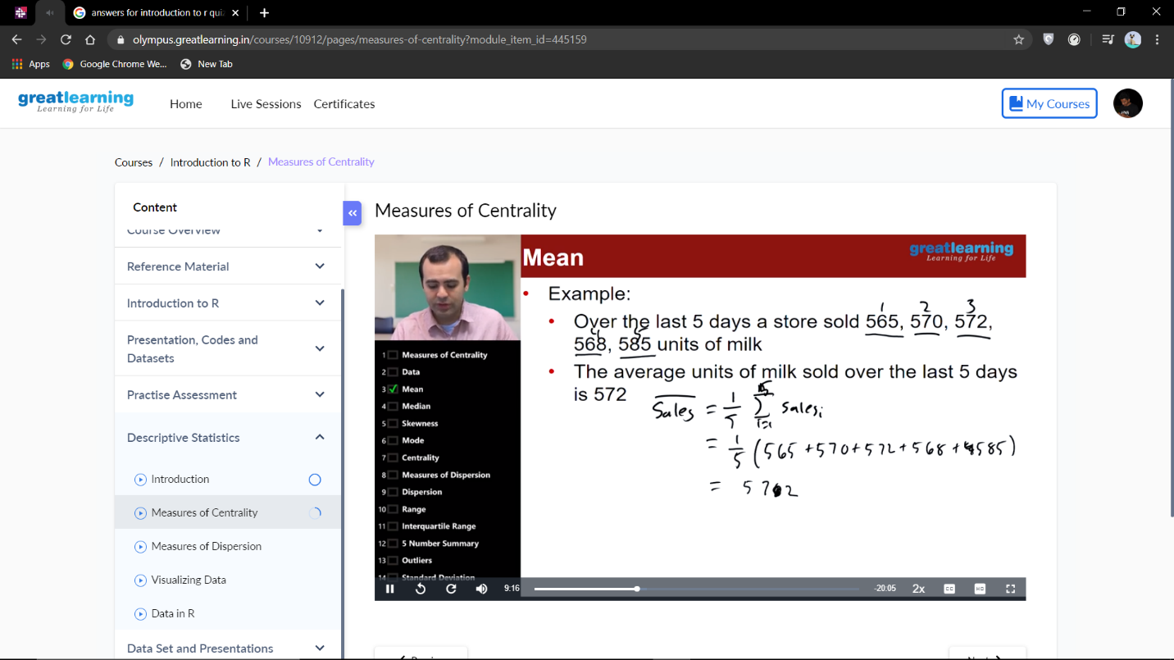

Coding Challenges Details:

**CODING CHALLENGES:**

Write a java program to calculate nPr. nPr represents n permutation r and value of nPr is (n!)/ (n-r)!

Input: The first line of the input contains T denoting the number of test cases. T test cases follow. First line of the test cases will be the value of n and r respectively.

Output: For each test case, in a new line, output will be the value of nPr.

Constraints:

1<=T<=100

1<=n, r<=20

n>=r

